Lab 4C - Cross-Validation

Directions: Follow along with the slides and answer the questions in **bold** font in your journal.

## Predictions

* In the previous lab, we learned how to calculate the *mean squared error* (MSE).
  + This let us measure how well our model predicts values of our y-variable.
* To really measure how well our *line of best fit* predicts people's heights, we want see how well we predict the heights of people that we haven't yet measured.
* To do this, we'll divide our data into two sets:
  + A *training* set used to build our model.
  + And a *testing* set we can use to measure how well our model predicts *new* data values.
* This method of dividing data into sets is called *cross-validation*.

## Why cross-validate?

* Data scientists are often tasked with predicting some aspect of future observations.
  + Relying on a single data set to both *train* and *test* models can lead to models that are so specific to the current batch of data that they're unable to make good predictions for these future observations.
* Cross-validating allows data scientists to measure how well their models predict new observations.
  + It also gives them the ability to compare different models to see which models make better/worse predictions.

## Splitting the data

* Waiting for new observations can take a long time. The U.S. takes a census of its population once every 10 years, for example.
* Instead of waiting for new observations, data scientists will take their current data and divide it into two distinct sets.
* For our arm_span data, fill in the blanks to create a training and testing data set.

set.seed(123)  
train_rows <- sample(1:____, size = 85)  
train <- slice(arm_span, ____)  
test <- slice(____, - ____)

* **Explain these lines of code and describe the train and test data sets.**

## set.seed then split

* When we split data, we're randomly separating our observations into *training* and *testing* sets.
  + It's important to notice that no single observation will be placed in both sets.
* Because we're splitting the data sets randomly, our models can will also vary slightly, person-to-person.
  + This is why it's important to use set.seed.
* By using set.seed, we're able to reproduce the random splitting so that each person's model outputs the same results.

*Whenever you split data into training and testing, always use set.seed first.*

## Building on training

* When splitting data into *training* and *testing* sets, we need to have enough observations in our data so that we can build a good model.
  + This is why we kept 85 observations in our training data.
* As data sets grow larger, we can use a larger proportion of the data to *test* with.
* Fit a *line of best fit* model to our training data and assign it the name best_train.

## Predicting on testing

* Now that our model has been built, we can use it to predict the values of height in our test data.
* Because we're using the *line of best fit*, we can use the predict() function we introduced in the last lab to make predictions.
  + Fill in the blanks below to add predicted heights to our test data:

test <- mutate(test, ____ = predict(best_train, newdata = ____))

* Calculate the MSE in the same way as you did in the previous lab.

## Avoiding being too specific

* When we build models without cross-validating, we run the risk of building models that are *too* specific to the data we already have.
  + Meaning, the model predicts values we know about really well BUT predicts new values very poorly.
* The plot on the following slide shows a single, randomly chosen height for each value of armspan.
  + **With a neighbor, write down a prediction rule that would predict a person's height based on their armspan really well for people already shown in our plot but would predict people not in our plot very poorly.**

## 

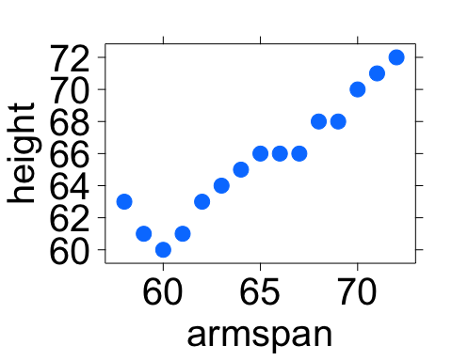

* **With a neighbor, write down a prediction rule that would predict a person's height based on their armspan really well for people already shown in our plot but would predict people not in our plot very poorly.**